Mass Provisioning of Nordic BLE Mesh Nodes

|  |  |  |
| --- | --- | --- |
| **Document version** | **Author** | **Comment** |
| Feb-7-2020 | MQ | Update for Mesh SDK 4.0.0. |
| Oct13-2019 | MQ | Initial document for Mesh SDK 3.2.0. |

# Purpose

When creating a mesh network with many nodes, it can take a while to provision each node, especially using PyACI. An alternative is to use a static provisioner that provisions the nodes automatically but that requires a dedicated node that is used for this purpose.

This document outlines the use of a Python script, meshfwpatch.py, that can take as input, firmware that has been ripped (read back from node’s flash and saved as an Intel Hex file using nrfjprog) from a provisioned node, update the device address and the device key in that firmware, write the updated firmware to a new file, and, finally, update the mesh database file. This allows for the quick generation of multiple firmware copies that can be flashed onto nodes. The nodes are, therefore, pre-provisioned from the start automatically. It is only required to manually provision one node and then that node’s firmware can be ripped and new copies of firmware generated using this script for any number of other nodes.

# Procedure

In this procedure, we will provision a node using PyACI, rip its firmware, and then use the meshfwpatch.py script to generate new firmware. We will then flash this firmware to a new node and observe it as coming up provisioned. This process can be extended to any number of nodes.

1. Connect a nRF52-DK to the PC via USB cable and launch the Segger Embedded Studio (SES) with the project in <Mesh SDK>/examples/serial/ directory.
2. Compile, flash, and run the serial firmware on the nRF52-DK.
3. Follow instructions [here](https://www.nordicsemi.com/en/DocLib/Content/SDK_Doc/Mesh_SDK/v3-1-0/md_scripts_interactive_pyaci_README) to install Python 3 and launch the PyACI tool under <Mesh SDK>/scripts/interactive_pyaci/:

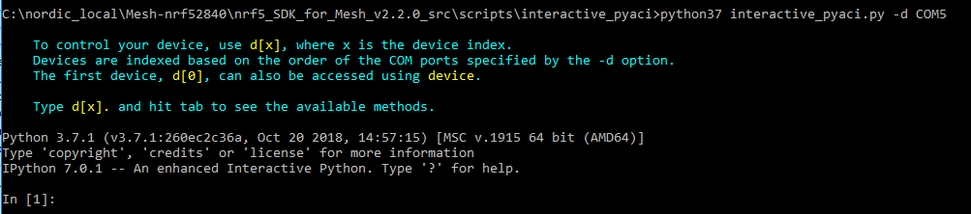

1. Connect another nRF52-DK to the PC via USB cable and launch the Segger Embedded Studio (SES) with the project in <Mesh SDK>/examples/light_switch/server/ directory.
2. Compile, flash, and run the light switch server firmware on the nRF52-DK.
3. We need to start with a fresh JSON file which will hold the database of the mesh network. This file resides in the <Mesh SDK>/scripts/interactive_pyaci/database/ directory. Note that this file can be edited by humans since it is human-readable JSON format. Copy “example_database.json.backup” to “example_database.json” in the same folder. Overwrite, if needed. This will be a necessary step each time only when provisioning a brand-new network.
4. Now we will provision the light switch server node. In PyACI shell, type in the highlighted input:

In **[**1**]:** db **=** MeshDB**(**"database/example_database.json"**)**

In **[2]:** p = Provisioner(device, db)

In **[**4**]:** p**.**scan_start**()**

In **[**5**]:** p**.**scan_stop**()**

In **[**6**]:** p**.**provision**(**name**=**"Light bulb"**)**

In **[**7**]:** cc **=** ConfigurationClient**(**db**)**

In **[**8**]:** cc**.**force_segmented **=** **True**

In **[**9**]:** device**.**model_add**(**cc**)**

In **[**10**]:** cc**.**publish_set**(**8**,** 0**)**

In **[**11**]:** cc**.**composition_data_get**()**

In **[**12**]:** cc**.**appkey_add**(**0**)**

In **[**13**]:** cc**.**appkey_add**(**1**)**

In **[**14**]:** cc**.**model_app_bind**(**db**.**nodes**[**0**].**unicast_address**,** 0**,** mt**.**ModelId**(**0x1000**))**

This should provision the node.

1. Launch a command line window, go the <Mesh SDK>/scripts/interactive_pyaci/ directory, and issue the following command to rip the firmware from the provisioned light switch server node:

nrfjprog --family nrf52 --readcode dump_nRF52832_mesh_server_provisioned.hex

1. Copy the meshfwpatch.py script to the <Mesh SDK>/scripts/interactive_pyaci/ directory. The script has been tested to run only from this directory.
2. Now we will look at the mesh database file to see the information of the provisioned node. We can manually read the mesh database file, as it is in human readable JSON format, or we can use the meshfwpatch.py script to parse it for use and show us the node information. We will use the latter so type the following command:

python meshfwpatch.py --list-info database\example_database.json

1. Observe the output (the device key will be unique and different, of course):

Index: 0

Node name: Light bulb

Device key: b432ad3a97e35032d0a5d2db871fdd17

Unicast address: 0x10

1. Type in the following command to generate three new pre-provisioned firmware copies:

python meshfwpatch.py --hex-input-file dump_nRF52832_mesh_server_provisioned.hex --db-input-file database\example_database.json --clone-copies 3 --hex-output-file nRF52832_mesh_server_provisioned_clone.hex

1. The generated files can now be flashed to a new node using nrfjprog. After flashing the nodes, switch the nodes off and then on and they should come up already pre-provisioned.
2. Let’s verify that the mesh database file has also been updated by issuing the same command to query the mesh database:

python meshfwpatch.py --list-info database\example_database.json

1. Observe the output with the added three nodes:

Index: 0

Node name: Light bulb

Device key: b432ad3a97e35032d0a5d2db871fdd17

Unicast address: 0x10

Index: 1

Node name: Light bulb_0011

Device key: 24b07e34e3b648ec840993d1acfe6bbf

Unicast address: 0x11

Index: 2

Node name: Light bulb_0012

Device key: a178f4436baf4c95a7c523e958a10011

Unicast address: 0x12

Index: 3

Node name: Light bulb_0013

Device key: d6132114a94d456eba0d3c51507412ec

Unicast address: 0x13

## Workflow

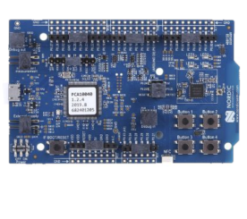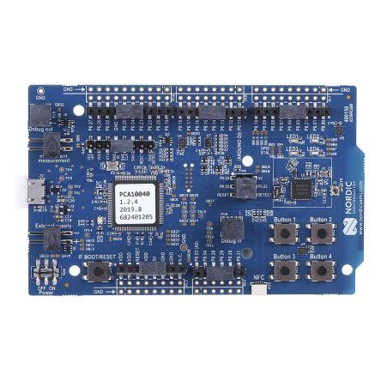

**Mesh Client Node 0**

**Mesh Server Node 0**

nrfjprog --read-code

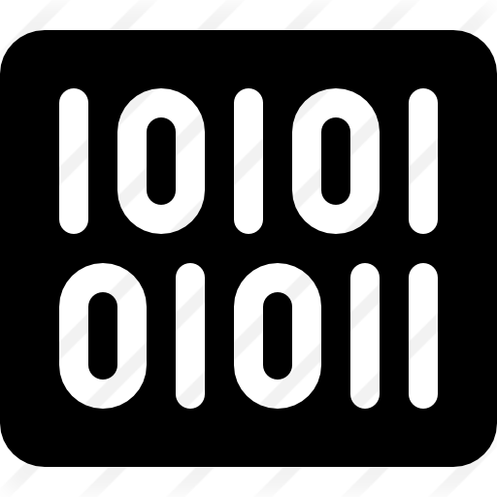

meshfwpatch.py

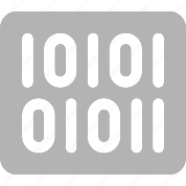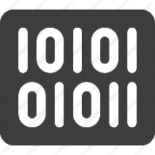

nrfjprog --program

Mesh Client 1 Firmware

Mesh Client 2 Firmware

Mesh Client 3 Firmware

Mesh Server 1 Firmware

Mesh Server 2 Firmware

Mesh Server 3 Firmware

Mesh Server 0 Firmware

Mesh Client 0 Firmware



**Mesh Server Node 1**

**Mesh Server Node 2**

**Mesh Server Node 3**

**Mesh Client Node 3**

**Mesh Client Node 2**

**Mesh Client Node 1**

NOTES:

* For different types of nodes in a mesh network, the first node needs to be manually provisioned and then it can be processed with the script to generate firmware for other nodes of the same type. For instance, if there is a light switch client node in the mesh network, the first client node is manually provisioned, and then other client nodes can reuse the firmware ripped from that client node after processing by the script.
* Use the -h parameter to have meshfwpatch.py script display a help screen.
* The device key and the unicast address are automatically generated but can be specified on the command line as well.
* The optional parameters to the script are --log-level, --node-name, --unicast-addr, --device-key, --start-node, --mesh-sdk-version, and --clone-copies.